ISSUES

NEUTON V1.46a
Font naming issues

OVERVIEW While the following points may not be an issue, they are worth noticing anyway because :
- other familly members do not exhibit same naming patterns
- same weight fonts with different names pile up upon installment generating puzzlement by choice. Kerning having susbtantially changed is also a matter when it comes to preserve a layout from collapse.

ANALYSIS

  - Extra light
    - Previous Neuton-ExtraLight
    - V1.46a Neuton-Extralight

  - Extra bold
    - Previous Neuton-ExtraBold
    - V1.46a Neuton-Extrabold

NEUTON V1.46a
visualization issues

  - Neuton Extra Bolds (old and new comparision)

    - The new 1.46a ttf release does not show up, really.

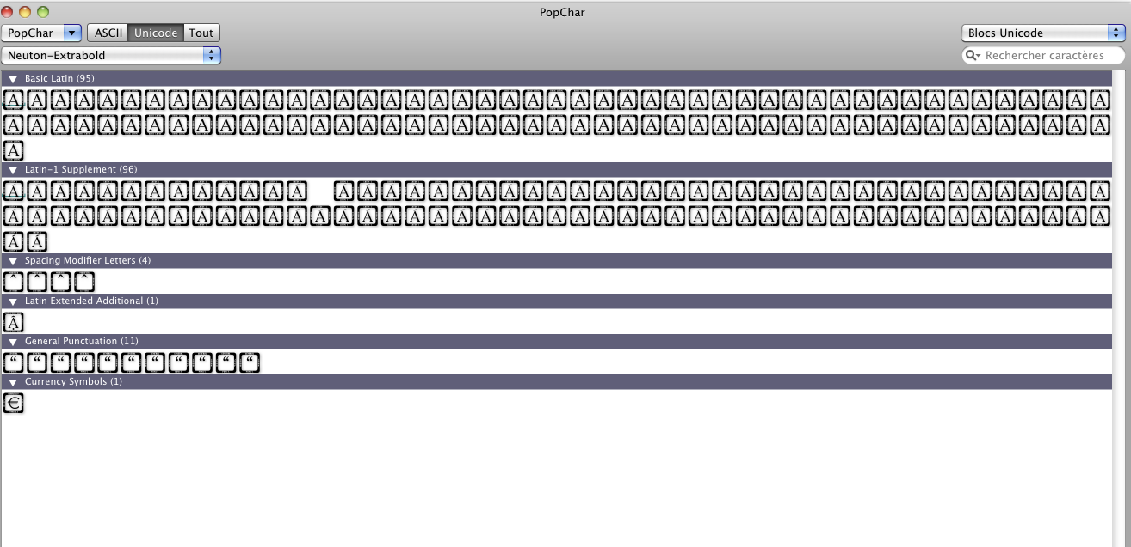

    - The old ttf release below

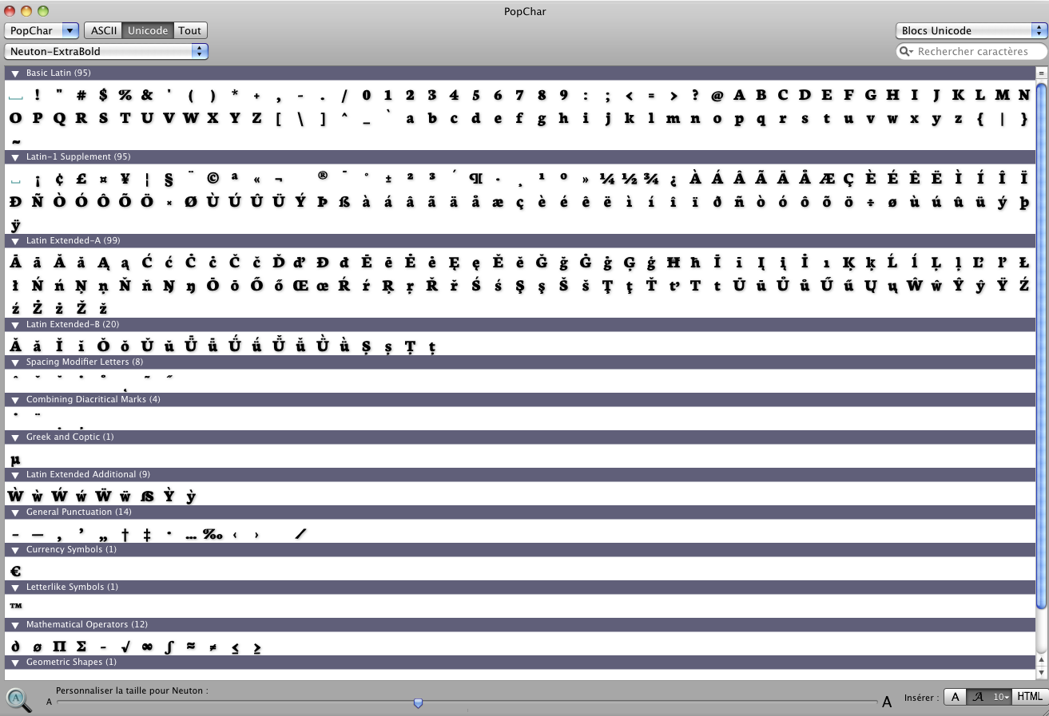
  - Neuton Extra Lights (old and new comparision)

    - The new 1.46a ttf release does not show up, really.

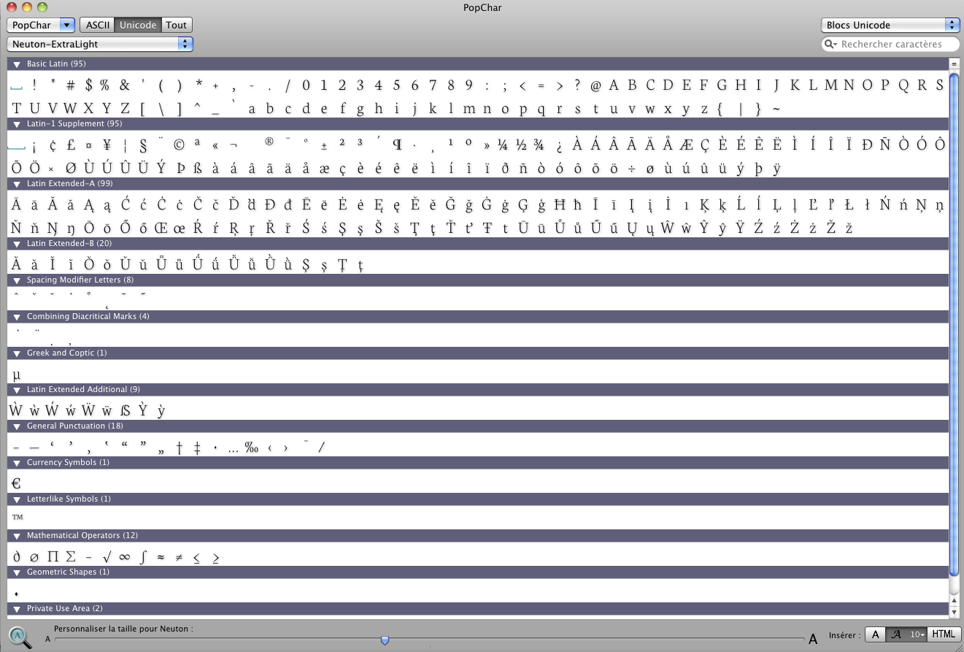

    - The old version shows up correctly

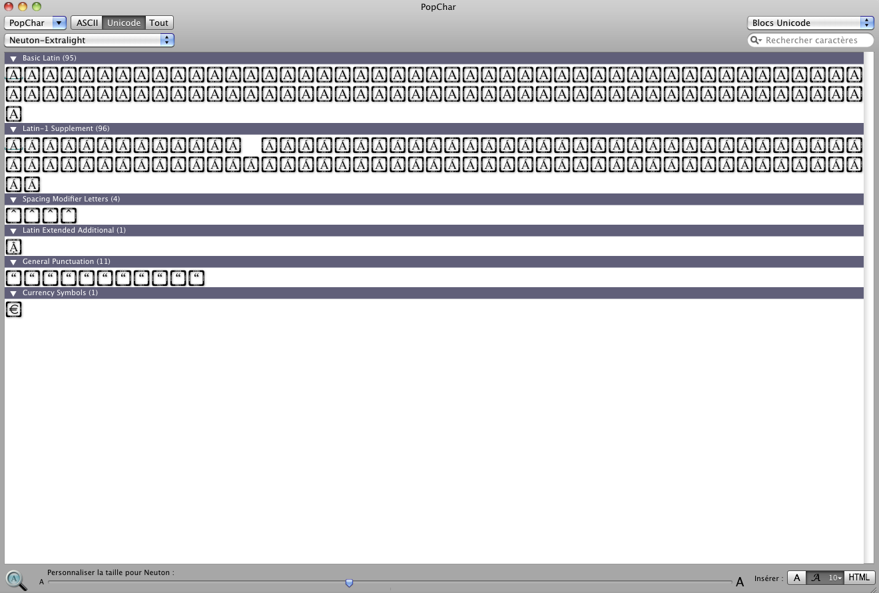

  - Neuton Alt Ital does not show up as ttf

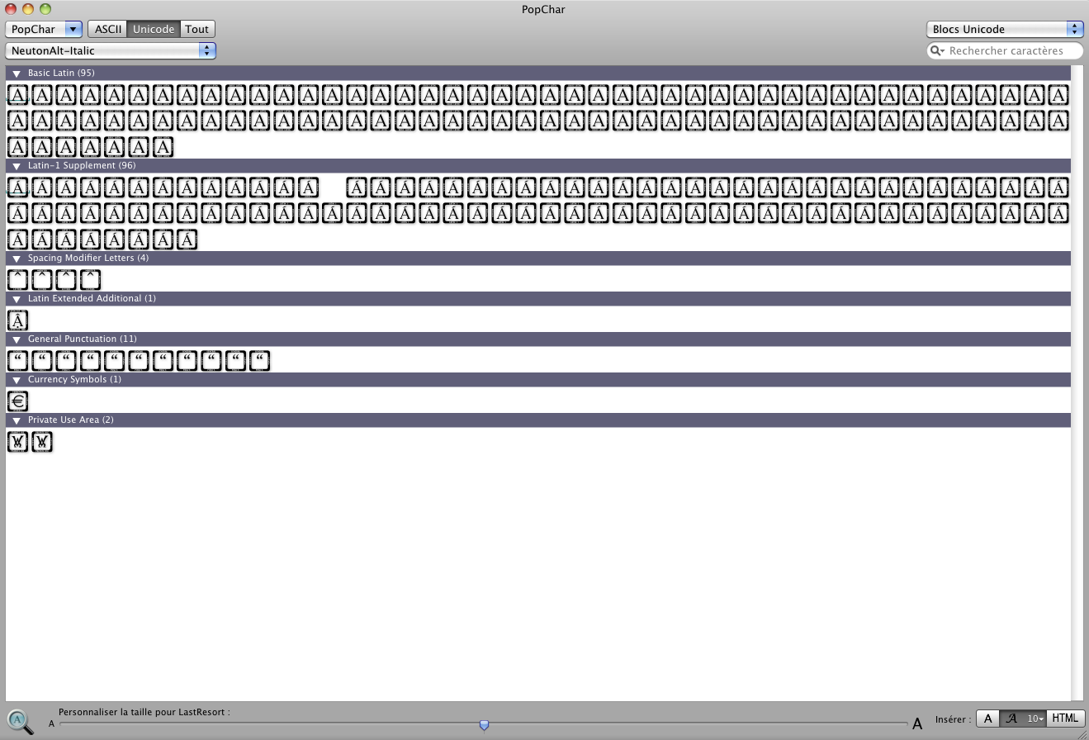

  - Neuton Extralightitalic does not show up

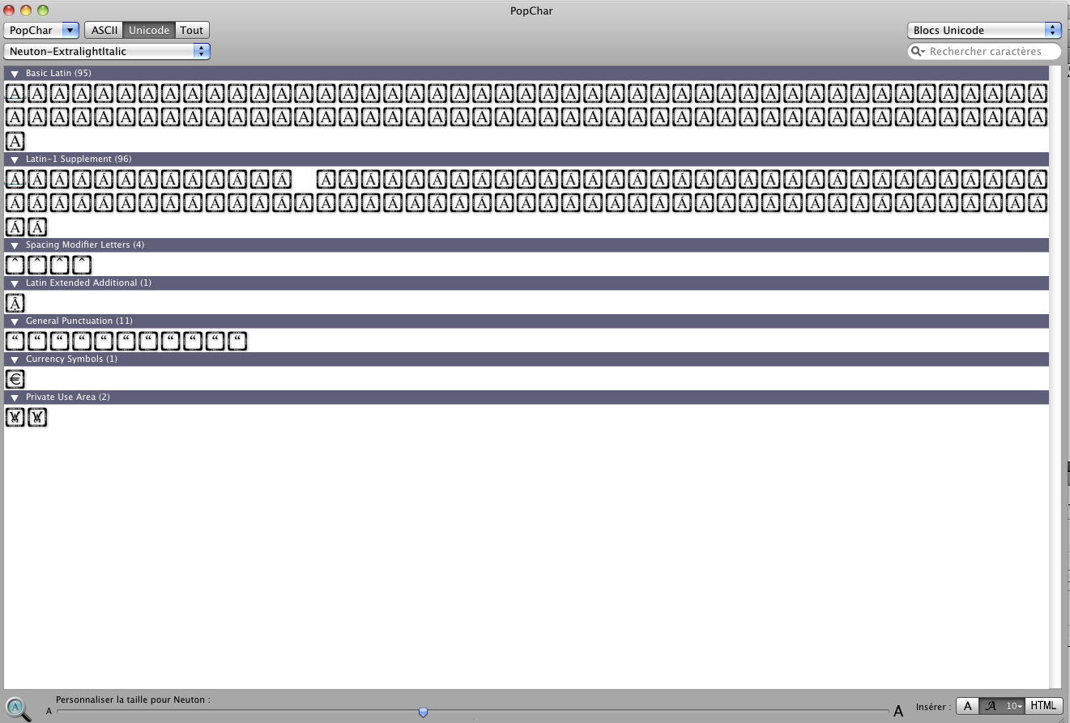

NEUTON V1.46a
Glyph coverage issues

- Neuton Bold, unexpected reduced glyph coverage, missing essential punctuation such as (one example only) :

…

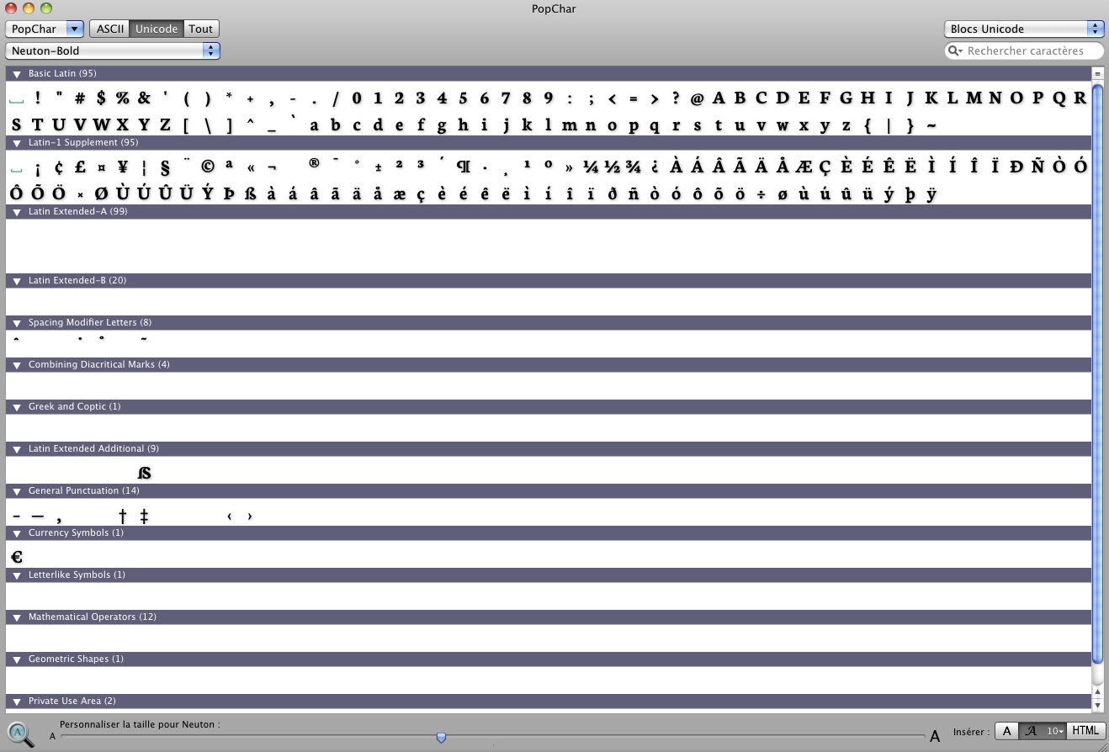

NEUTON V1.46a
Kerning glitch upon font change

